# PROJECT DESIGN PHASE - 1

SOLUTION ARCHITECTURE

|  |  |
| --- | --- |
| Date | 24 September 2022 |
| Team ID | **PNT2022TMID14052** |
| Project Name | **Real-Time River Water Quality Monitoring and Control System** |
| Maximum Marks | 4 Marks |

# SOLUTION ARCHITECTURE:

Solution architecture is a complex process – with many sub-processes – that bridges the gap between business problems and technology solutions. Its goals are to:

* Find the best tech solution to solve existing business problems.
* Describe the structure, characteristics, behaviour, and other aspects of the software to project stakeholders.
* Define features, development phases, and solution requirements.
* Provide specifications according to which the solution is defined, managed, and delivered.



WIFI/INTERNET

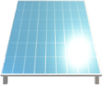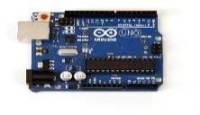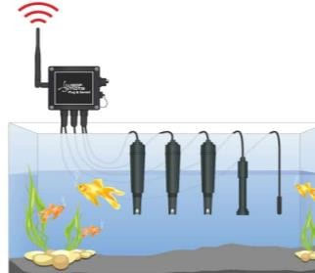

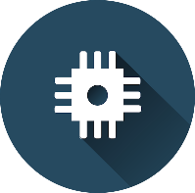IBM cloud

IOT WATSON PLATFORM

SOLAR POWERED

MCU

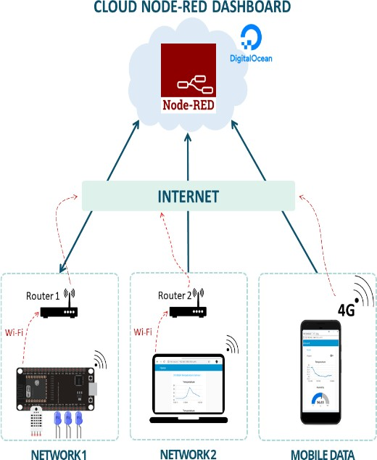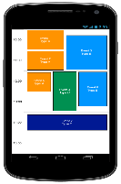

user interface

sensing water quality

python random data



FLASH SMS

REMOTE ACCESS